



By The Sandy LEGO Beachbots Team #37
Ian Schroeder, Lynda Morris,
Brannon Smudz,
Nadya, Ciara, and Brennan Dooley

Editing, compiling, and layout by Ian Schroeder

Drawings by Brennan Dooley

"Global warming will be the greatest environmental challenge in the 21st Century."
- Former Vice President, Albert Gore.

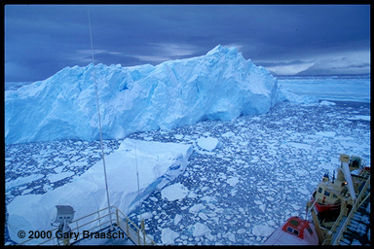
Hurricane Katrina, hurricane Rita, flooding in Europe and the northeast, and toxic algae blooms- is mother ocean angry? Is it our fault? What did we do and how can we begin to undo it? What will happen if this continues? Industrialization and deforestation by man have led to an increase in greenhouse gases in the atmosphere. A gas soup of water vapor, methane, carbon dioxide and ozone lets energy in but doesn’t let energy out causing higher global temperatures. The evident impacts are melting polar caps, rising seas levels, warming oceans, climate changes, and possibly more severe hurricanes. And the repercussions of these impacts extend to all forms of life. How do we put a halt to this snowballing – or rather “fire-balling” - catastrophe? The first is to understand it.

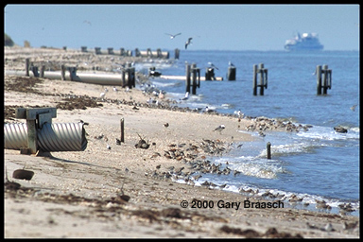
Greenhouse gas (water vapor, methane, carbon dioxide and ozone) lets the sunlight go in but not out. This is known as the greenhouse effect. The sun naturally sends out rays of ultraviolet light that hit the earth’s atmosphere. When it does, earth and its waters absorb most of the rays, and approximately 30% of the light is reflected back into space. Without that bit of reflected light, earth would burn up from the extreme heat. In fact, all of the light that the earth does absorb is then released back through the atmosphere – back into space. The temperature of earth is a delicate balance - one that can be easily disrupted.

Take the increase in carbon dioxide in the atmosphere over about the last three centuries as a striking example of the earth’s delicate balance. Before the beginning of the industrial age, the concentration of carbon dioxide in the atmosphere was approximately 280 ppm (parts per million). Today it's over 360 ppm. That's an increase of about 30% in less than 300 years. Also, in 2003, the US released 5760.1 million metric tons of carbon dioxide through the production of electricity (the largest source of carbon dioxide annually in the US). By burning the fossil fuels for electricity we are increasing the amount of greenhouse gases in the atmosphere, thereby inevitably leading to global warming.

Fossil fuel is oil, coal, and natural gas, which were formed from the remains of plants and animals that lived millions of years ago before the dinosaurs. This organic material was covered by mud and rock, heat and pressure from these layers turned it into what is known as fossil fuel.

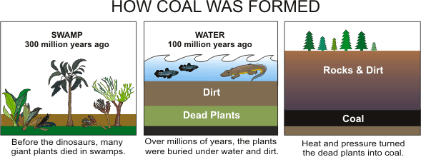

Oil and gas can be burned in their natural state, but coal is smashed into dust before it is burned, to create electrical power. Fossil fuel is burned to heat water. The hot water turns into steam that turns turbine generators. This creates electrical power that is sent all over the world. This power is around 66% of the world’s electrical power and 95% of the world’s total energy demands (including heating, transportation, electrical generation, and other uses). And – voila – we have global warming.
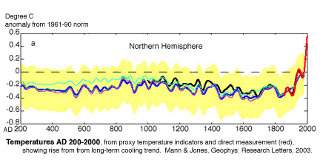
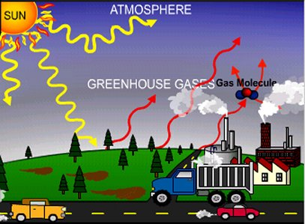
Global warming is caused by greenhouse gases rising up into the atmosphere as a result of burning coal and other fossil fuels, tearing down forests and driving cars. This makes the atmosphere “thicken” over time. Now that the atmosphere is denser, the absorbed heat sent out by the earth rebounds and goes back to the earth. With the combination of the sun putting more energy into our planet and the heat released from the earth not getting through the atmosphere, the net flow of temperature on this planet will go up (imagine that you're stuck in a car with the windows rolled up and no air-condition on a hot summers day. That’s what the earth is like). This increase of temperature is causing (and will continue to do so if we don't do something) melting ice caps, rising sea levels, warming oceans and climate changes that will in turn destroy coral reefs, coastal bird habitats and coastal structures.

Warming water is destroying coral reefs and inhibiting their growth. Temperatures above normal cause the coral to release zooxanthellae, a microscopic organism that lives with the coral. If this continues for days on end, the coral dies and algae take over what’s left. Furthermore, the ocean, by increasing in temperature, dissolves the carbon dioxide in the water, which causes the water to acidify, slowing the growth rate of coral.

Also, water expands as it gets hotter and causes the sea levels to rise. That coupled with the ice in the north and south melting, which creates more water, the sea levels will rise very quickly (estimated to increase about a meter by 2100). This will affect coral, which thrives better near the surface of the water.
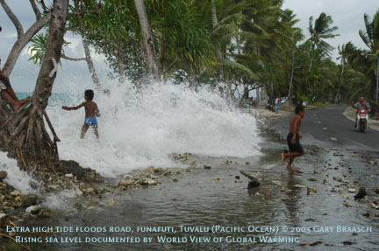
Many migratory animals are suffering due to major migration places, such as Delaware Bay, shrinking because of rising sea levels. With less beach space, birds such as sandpipers, red knots, and turnstones have less room to forge for their main food: horseshoe crab eggs.

Erosion is a big problem for coastal cities and structures. The Hatteras Lighthouse, one of the U.S.’s most famous lighthouses, has already been moved to higher ground for protection. Along Cape Hatteras the erosion level has been at about 12’ per year, putting nearby housing in a bad position. The Federal movements of trying to put sand back on the beaches actually increase the erosion damage over time.

Can we stop global warming? Is there a reasonable, effective solution that can be quickly put into action?

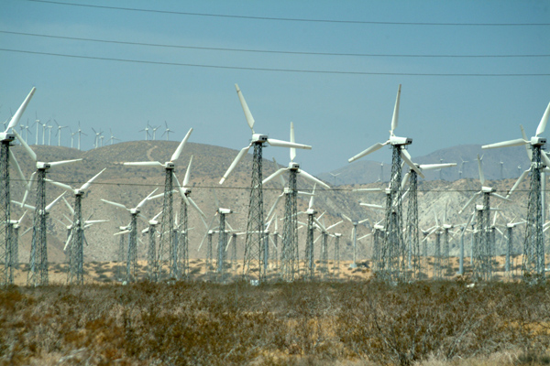
Increasing our use of renewable resources instead of our dependence on fossil fuels would help decrease global warming. Most people are familiar with solar, wind, and hydropower. But ocean energy is not so well known. One of the benefits of ocean energy is that it unlike solar and wind energy, it is always available.

There are five ways to get energy from the ocean. They are ocean wave energy, ocean tidal energy, ocean thermocline energy, and ocean current energy and salinity gradient energy.

Ocean wave energy generates electricity by the up-and-down motion of the waves. In the Isle of Islay, Scotland, the first commercial wave energy plant, .5 mega-watts was developed by WaveGen. There is also a wave-energy plant under construction off the coast of Portugal.
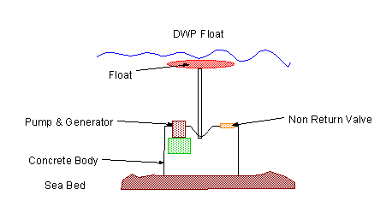
Wave energy generator diagram.

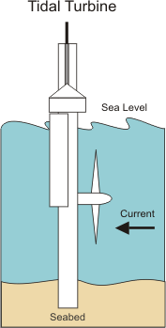
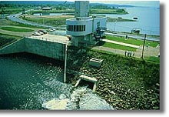
Ocean tidal energy works because when the tide goes in, the water level goes up and when it goes out it goes down into a turbine system. There are only about 20 places in the world where you can do this because the tidal range has to be about 10 feet. There are two places, one in La Rance, France and the other in Annapolis Royal, Nova Scotia Canada were commercial sized facilities are in operation.
Annapolis Royal Tide Generating Station

Ocean thermocline energy uses the difference in temperature between the surface water and the deep water. It must have a temperature difference of at least 25° Celsius to work so it can only be used in tropical regions. Small-scale designs are in use in Japan and Hawaii. The one in Japan produces 100 KW and the one in Hawaii produces 50 KW of electricity.
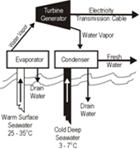
Ocean current energy makes use of the currents that are always flowing in the ocean. The swift continuous currents moving close to shore, like the Florida Current and the Gulf Stream Current in the US, are sources that are most likely to be used because are close to areas where there is a demand for power. It can also be useful around islands where there is a need for electricity.
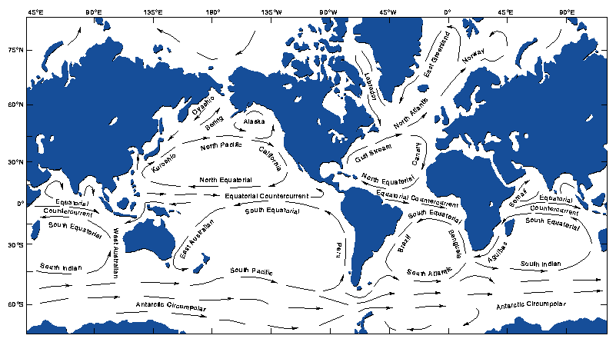
Salinity gradient energy uses the difference in density between freshwater and seawater. A hydrocratic generator uses the higher density of ocean water and the lower density of fresh water to turn a turbine and produce electricity. Possible benefits could be drinking water (through desalinization) and energy generation at the same time.

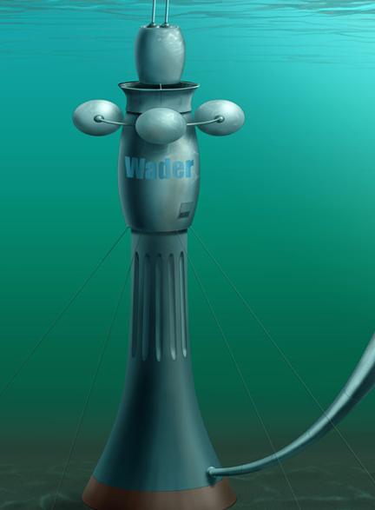
Wader holds a patent on a method of generating energy through a process involving the mixing of salt and fresh water. This device is called the Hydrocratic Generator.

This is a design for an offshore power generator/ocean research platform, Aquatic Solutions to Air Pollution, known by its acronym, ASAP..(see diagram A). This platform generates power by using a combination of currents (diagram B), wave energy (diagram C), and salinity gradient (diagram D). It also filters out harmful materials and useful minerals from the water.

The entire platform is surrounded by a ring of salinity gradient power generators. These generators are used to filter out the harmful materials and useful minerals at the same time as they are generating power.

Between the platform and the salinity gradient power generators is ring of buoys that utilize the up-and-down motion of waves to generate power. The buoy is attached to the pump by a cable and the pump is attached to the sea floor by a series of pistons that can be moved up and down and the tide changes. One of the special features of this platform as the tide increases it pressurized the pistons, which raises the pump (see diagram E).

Mounted on the bottom of the station are current generators. These are like underwater wind turbines. Underwater turbines don’t need to be as large as wind turbines because sea water is 832 times as dense as air, which gives a 5 knot ocean current more kinetic energy than a 350 km/h wind.

Diagram C Wave Energy Generator Ggenerator

Diagram A Entire platform (bottom)
Diagram A Entire platform (top)
Diagram A Entire platform (side)
Diagram B Current turbine

Diagram E tide sensor

Diagram F batteries and storage tank

Probe bay
Dock
Buildings

Diagram D
Salinity gradient generator

Diagram B Current turbine

Diagram C Wave generator

Diagram E tide sensor

Diagram D
Salinity gradient generator

Yet before our earth becomes a desolate island we can take a closer look. Surrounding an island there is always water – an ocean of water. Our lifeboat can be “built” from this ocean water. If we choose to increase our use of renewable resources, develop the necessary technologies and focus on the power of ocean energy, we might be able to survive.

By using renewable resources instead of fossil fuel we can lower the output of carbon dioxide into the atmosphere, while still maintaining the electricity we use daily. Also, there is a limited amount of fossil fuel left in this world with which to use. Eventually, if we don’t do anything about it, we will run out of fossil fuel. If that happens, not only will we lose almost all of our electricity, but we also won’t be able to build anything to bring it back.

The earth is coming to a point in time where, if we don't be careful, the earth won't be earth any longer. While the earth's supply of resources start to decrease, the demand for them will increase due to the earth's population increase. If we don’t curb our seemingly insatiable appetites, eventually we are going to run out of resources altogether. When that happens, we will be cast away on an “island” with no one to rescue us – responsible for our own fate. Then, a combination of “natural” disasters (such as rising sea-levels, erosion, fire, etc) will wear away at the “island” – leaving nowhere to go, no where to live.
What will be our fate? If we continue to live as we do, we will destroy our world. Our world will never be the same. We are now headed toward that “island of destruction”. Can we change the future? Only if we boldly act now!

Bibliography

Energy Information Administration (2005). Greenhouse Gases, Climate Changes, and Energy [online]. Washington D.C. Available from: <http://www.eia.doe.gov/oiaf/1605/ggccebro/chapter1.html>
[Accessed Fall 2005]

Partial Ocean Energy Management Systems (2004). POEMS' Role is to Educate, Fund and Ocean Test [online]. San Diego, CA. Available from:www.poemsinc.org <http://www.poemsinc.org>
[Accessed Fall 2005]

California Energy Commission (2005). Ocean Energy [online]. Sacramento, CA. Available from: <http://www.energy.ca.gov/development/oceanenergy/>
[Accessed Fall 2005]

U.S. Department of Energy (2005). Energy Efficiency and Renewable Energy [online]. Annapolis, MD. Available from:
<http://www.eere.energy.gov/RE/ocean.html>
[Accessed Fall 2005]

<http://europa.eu.int/comm/energy_transport/atlas/htmlu/wave.html>
Annapolis Tidal Generation Station (2005). Tidal Power [online].
Annapolis, MD. Available from: <http://collections.ic.gc.ca/western/tidal.html>
[Accessed Fall 2005]

Natural Resource Defense Council (2005). Polar Bears on Thin Ice [online].Available from: <http://www.savebiogems.org/polar/takeaction.asp?step=1>
[Accessed all 2005]

www.freefoto.com <http://www.freefoto.com>
[Accessed Fall 2005]

http://upload.wikimedia.org/wikipedia/en/7/78/Fuel_shares_world_electricity_generation.png>
[Accessed Fall 2005]

California Energy Commission (2002). Energy Story-Chapter Eight: Fossil Fuels-Coal Oil and Natural Gas [online]. Sacramento, CA. Available from:
<http://www.energyquest.ca.gov/story/chapter08.html>
[Accessed Fall 2005]

Darvill, Andy (2005). Energy Resources: Fossil Fuel [online]. England. Available from: <http://www.darvill.clara.net/altenerg/fossil.htm>
[Accessed Fall 2005]

Available from: www.epa.gov <http://www.epa.gov>
[Accessed Fall 2005]

Sea Solar Power International. Ocean Thermal Energy Conversion Technology [online]. Jacobus, PA. Available from:
<http://www.seasolarpower.com/otec.html>
[Accessed Fall 2005]

Gary Braasch (2005). World View of Global Warming [online]. Nehalem, OR. Available from: http://www.worldviewofglobalwarming.org/. [Accessed Fall 2005]

Green, Kenneth. Global Warming. Berkeley Height, NJ: Enslow Publishers, 2002

Friedman, Katherine. What if the Polar Ice Caps Melted?. U.S.: Scholastics, 2002

Scoones, Simon. Climate Change: our Impact on the Planet. Austin, TX: Raintree Steck-Vaughn Publishers, 2002

“Ocean Power Delivery Wave Farm”, Popular Science, December, 2005.

"Photos from wwww.worldviewofglobalwarming.org © 2005. Used with permission"

Some photos supplied by FreeFoto.com

